EXERCISE NO:10

REGISTER NO:1518102103

Name:S.PREYATHARSENI

AIM: TO write a program print the number of upper case letters and lower case letters in a given string.

Program:

def string_test(s):

d={"UPPER_CASE":0, "LOWER_CASE":0}

for c in s:

if c.isupper():

d["UPPER_CASE"]+=1

elif c.islower():

d["LOWER_CASE"]+=1

else:

pass

print ("Original String : ", s)

print ("No. of Upper case characters : ", d["UPPER_CASE"])

print ("No. of Lower case characters : ", d["LOWER_CASE"])

s=input()

string_test(s)

link: <http://103.53.53.18/mod/vpl/forms/submissionview.php?id=317&userid=1707>

output:

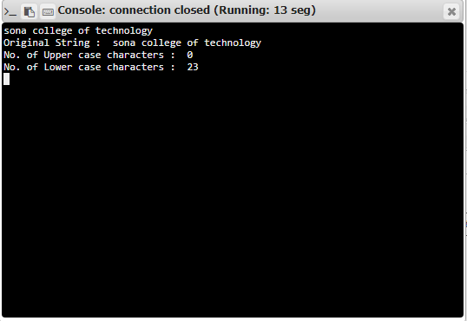

fffew

Result:

Thus, the code has been successfully executed and output is verified. ­­­­­